CEEDS_OpenADR_ReferenceEnergyCurveMinMaxOperatingEnvelope Document assembly model

Overview of the model

!# 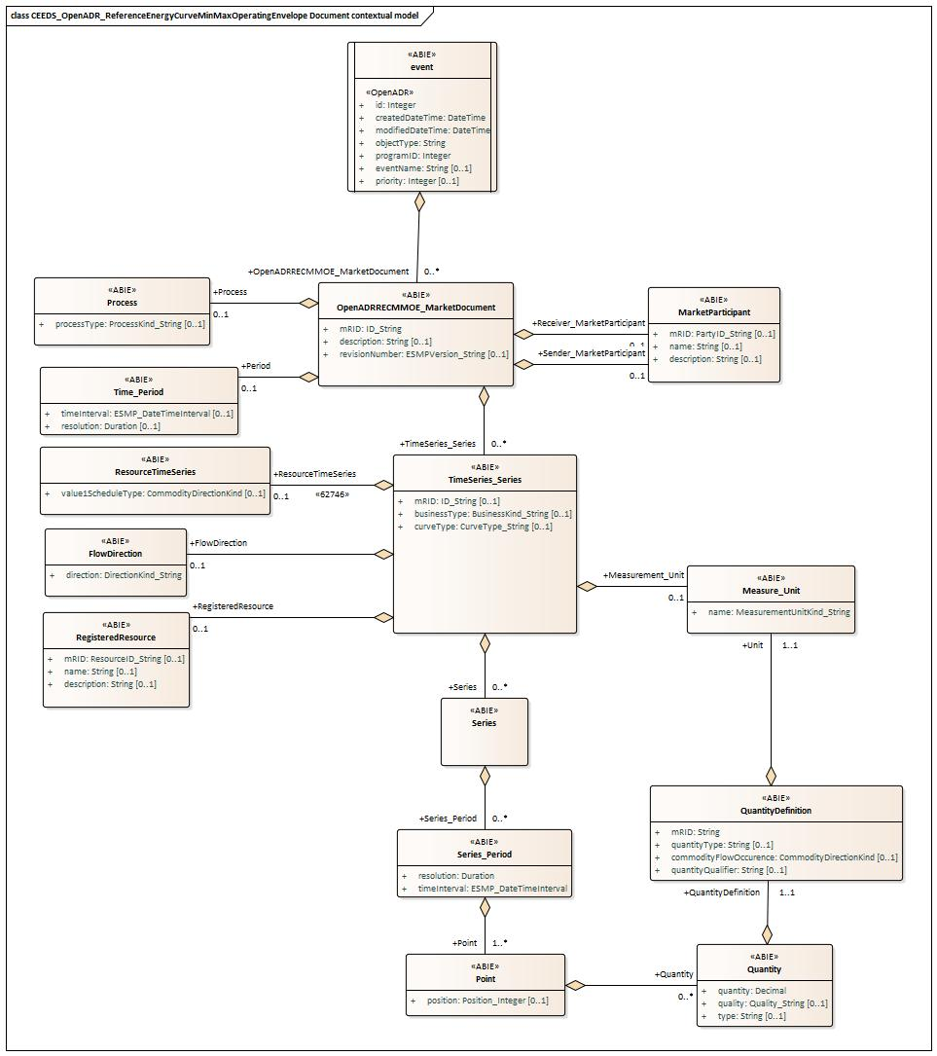shows the model.

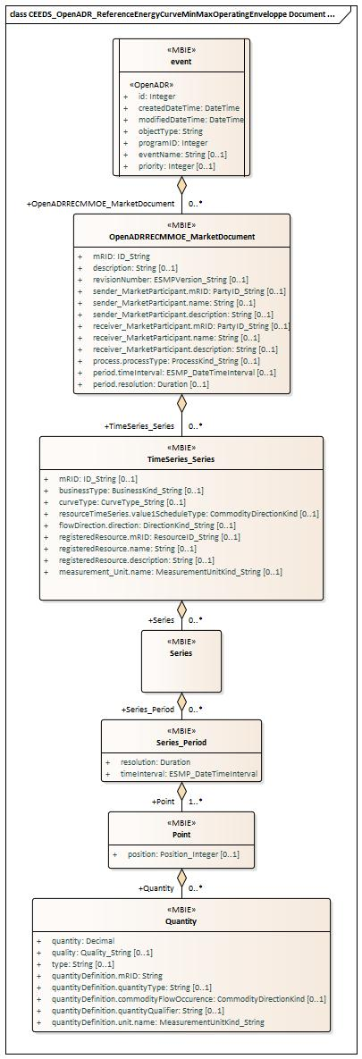

Figure !# - CEEDS_OpenADR_ReferenceEnergyCurveMinMaxOperatingEnvelope Document assembly model

IsBasedOn relationships from the European style market profile

!# shows the traceability dependency of the classes used in this package towards the upper level. Table !# - IsBasedOn dependency

Name Complete IsBasedOn Path

event CIMProfiles::MarketProfiles::RD_Projects::CEEDS::CEEDS_OpenADR_ReferenceEnergyCurveMinMaxOperatingEnvelope Document::CEEDS_OpenADR_ReferenceEnergyCurveMinMaxOperatingEnvelope Document assembly model::event

OpenADRRECMMOE_MarketDocument CIMProfiles::MarketProfiles::RD_Projects::CEEDS::CEEDS_OpenADR_ReferenceEnergyCurveMinMaxOperatingEnvelope Document::CEEDS_OpenADR_ReferenceEnergyCurveMinMaxOperatingEnvelope Document assembly model::OpenADRRECMMOE_MarketDocument

Point CIMProfiles::MarketProfiles::RD_Projects::CEEDS::CEEDS_OpenADR_ReferenceEnergyCurveMinMaxOperatingEnvelope Document::CEEDS_OpenADR_ReferenceEnergyCurveMinMaxOperatingEnvelope Document assembly model::Point

Quantity CIMProfiles::MarketProfiles::RD_Projects::CEEDS::CEEDS_OpenADR_ReferenceEnergyCurveMinMaxOperatingEnvelope Document::CEEDS_OpenADR_ReferenceEnergyCurveMinMaxOperatingEnvelope Document assembly model::Quantity

Series CIMProfiles::MarketProfiles::RD_Projects::CEEDS::CEEDS_OpenADR_ReferenceEnergyCurveMinMaxOperatingEnvelope Document::CEEDS_OpenADR_ReferenceEnergyCurveMinMaxOperatingEnvelope Document assembly model::Series

Series_Period CIMProfiles::MarketProfiles::RD_Projects::CEEDS::CEEDS_OpenADR_ReferenceEnergyCurveMinMaxOperatingEnvelope Document::CEEDS_OpenADR_ReferenceEnergyCurveMinMaxOperatingEnvelope Document assembly model::Series_Period

TimeSeries_Series CIMProfiles::MarketProfiles::RD_Projects::CEEDS::CEEDS_OpenADR_ReferenceEnergyCurveMinMaxOperatingEnvelope Document::CEEDS_OpenADR_ReferenceEnergyCurveMinMaxOperatingEnvelope Document assembly model::TimeSeries_Series

##MXM##

Detailed CEEDS_OpenADR_ReferenceEnergyCurveMinMaxOperatingEnvelope Document assembly model

event root class

!# shows all attributes of event.

Table !# - Attributes of CEEDS_OpenADR_ReferenceEnergyCurveMinMaxOperatingEnvelope Document assembly model::event Order mult. Attribute name / Attribute type Description

0 [1..1] id

Integer
- [1..1] createdDateTime

DateTime
- [1..1] modifiedDateTime

DateTime
- [1..1] objectType

String
- [1..1] programID

Integer
- [0..1] eventName

String
- [0..1] priority Integer
Identification of the event

Date and time this event has been created

Date and time this event has been modified

Used as discriminator.

ID attribute of the program object the event is associated with.

User defined string for use in debugging or User Interface.

Relative priority of event. A lower number is a higher priority.

##MXM##

!# shows all association ends of event with other classes.

Table !# - Association ends of CEEDS_OpenADR_ReferenceEnergyCurveMinMaxOperatingEnvelope Document assembly model::event with other classes Order mult. Class name / Role Description
- [0..*] OpenADRRECMMOE_MarketDocument
Association Based On :
OpenADRRECMMOE_MarketDocument CEEDS_OpenADR_ReferenceEnergyCurveMinMaxOperatingEnvelope Document contextual
model::event.[]

CEEDS_OpenADR_ReferenceEnergyCurveMinMaxOperatingEnvelope Document contextual model::OpenADRRECMMOE_MarketDocument.OpenADRRECMMOE_MarketDocument[0..*]

##MXM##

OpenADRRECMMOE_MarketDocument

An electronic document containing the information necessary to satisfy the requirements of a given business process.

!# shows all attributes of OpenADRRECMMOE_MarketDocument.
Table !# - Attributes of CEEDS_OpenADR_ReferenceEnergyCurveMinMaxOperatingEnvelope Document assembly model::OpenADRRECMMOE_MarketDocument
Order mult. Attribute name / Attribute type |  | Description
0 | [1..1] mRID  ID_String | The unique identification of the document being exchanged within a business process flow.  In the ESMP context, the "model authority" is defined as a party (originator of the exchange) that provides an identification in the context of a business exchange such as document identification, ...  Master resource identifier issued by a model authority. The mRID is globally unique within an exchange context.  Global uniqueness is easily achieved by using a UUID for the mRID. It is strongly recommended to do this. For CIMXML data files in RDF syntax, the mRID is mapped to rdf:ID or rdf:about attributes that identify CIM  object elements.
1 | [0..1] description  String | The description is a free human readable text describing or naming the object. It may be non unique and may not correlate to a naming hierarchy.
2 | [0..1] revisionNumber  ESMPVersion_String | The identification of the version that distinguishes one evolution of a document from another.
3 | [0..1] sender_MarketParticipant.mRID PartyID_String | The identification of a party in the energy market.  In the ESMP context, the "model authority" is defined as an authorized issuing office that provides an agreed identification coding scheme for market participant, domain, measurement point, resources (generator, lines, substations, etc.) identification.  Master resource identifier issued by a model authority. The mRID is globally unique within an exchange context.  Global uniqueness is easily achieved by using a UUID for the mRID. It is strongly recommended to do this. For CIMXML data files in RDF syntax, the mRID is mapped to rdf:ID or rdf:about attributes that identify CIM  object elements.
4 | [0..1] sender_MarketParticipant.name  String | The name is any free human readable and possibly non unique text naming the object.
5 | [0..1] sender_MarketParticipant.description The description is a free human readable text describing or naming the object. It may be non unique and may not correlate to a naming hierarchy.

String
- [0..1] receiver_MarketParticipant.mRID PartyID_String

- [0..1] receiver_MarketParticipant.name String

The identification of a party in the energy market.

In the ESMP context, the "model authority" is defined as an authorized issuing office that provides an agreed identification coding scheme for market participant, domain, measurement point, resources (generator, lines, substations, etc.) identification.

Master resource identifier issued by a model authority. The mRID is globally unique within an exchange context.
Global uniqueness is easily achieved by using a UUID for the mRID. It is strongly recommended to do this. For CIMXML data files in RDF syntax, the mRID is mapped to rdf:ID or rdf:about attributes that identify CIM object elements.
The name is any free human readable and possibly non unique text naming the object.

- [0..1] receiver_MarketParticipant.description The description is a free human readable text describing or naming the object. It may be non unique and may
not correlate to a naming hierarchy.

String
- [0..1] process.processType

ProcessKind_String
- [0..1] period.timeInterval

ESMP_DateTimeInterval
- [0..1] period.resolution

Duration

The identification of the nature of process that the document addresses.
--- The Process associated with an electronic document header that is valid for the whole document. The start and end date and time for a given interval.
--- The time interval that is associated with an electronic document and which is valid for the whole document. The number of units of time that compose an individual step within a period.
--- The time interval that is associated with an electronic document and which is valid for the whole document.

##MXM##

!# shows all association ends of OpenADRRECMMOE_MarketDocument with other classes.

Table !# - Association ends of CEEDS_OpenADR_ReferenceEnergyCurveMinMaxOperatingEnvelope Document assembly model::OpenADRRECMMOE_MarketDocument with other classes
Order mult. Class name / Role Description
- [0..*] TimeSeries_Series The time series that is associated with an electronic document. Association Based On :
TimeSeries_Series CEEDS_OpenADR_ReferenceEnergyCurveMinMaxOperatingEnvelope Document contextual
model::OpenADRRECMMOE_MarketDocument.[]

CEEDS_OpenADR_ReferenceEnergyCurveMinMaxOperatingEnvelope Document contextual model::TimeSeries_Series.TimeSeries_Series[0..*]

##MXM##

Point

The identification of the values being addressed within a specific interval of time.

!# shows all attributes of Point.

Table !# - Attributes of CEEDS_OpenADR_ReferenceEnergyCurveMinMaxOperatingEnvelope Document assembly model::Point Order mult. Attribute name / Attribute type Description

- [0..1] position Position_Integer
A sequential value representing the relative position within a given time interval.

##MXM##

!# shows all association ends of Point with other classes.

Table !# - Association ends of CEEDS_OpenADR_ReferenceEnergyCurveMinMaxOperatingEnvelope Document assembly model::Point with other classes

Order mult. Class name /
Role
- [0..*] Quantity Quantity
Description

The Quantity information associated with a given Point. Association Based On :
CEEDS_OpenADR_ReferenceEnergyCurveMinMaxOperatingEnvelope Document contextual model::Point.[]

CEEDS_OpenADR_ReferenceEnergyCurveMinMaxOperatingEnvelope Document contextual model::Quantity.Quantity[0..*]

##MXM##

Quantity

Description of quantities needed in the data exchange.

The type of the quantity is described either by the role of the association or the quantityType attribute. The quality attribute provides the information about the quality of the quantity (measured, estimated, etc.).
!# shows all attributes of Quantity.

Table !# - Attributes of CEEDS_OpenADR_ReferenceEnergyCurveMinMaxOperatingEnvelope Document assembly model::Quantity Order mult. Attribute name / Attribute type Description

- [1..1] quantity

Decimal
- [0..1] quality

Quality_String
2 [0..1] type

String
- [1..1] quantityDefinition.mRID

String

- [0..1] quantityDefinition.quantityType String
The quantity value.
The association role provides the information about what is expressed. The description of the quality of the quantity.

The description of the type of the quantity.

Master resource identifier issued by a model authority. The mRID is unique within an exchange context. Global uniqueness is easily achieved by using a UUID, as specified in IETF RFC 4122, for the mRID. The use of UUID is strongly recommended.
For CIMXML data files in RDF syntax conforming to IEC 61970-552, the mRID is mapped to rdf:ID or rdf:about attributes that identify CIM object elements.
Describes an observable property that can be measured and quantified numerically. Electricity related examples are ActivePower, ReactivePower, ActiveEnergy, ReactiveEnergy.

- [0..1] quantityDefinition.commodityFlowOccurence The direction of flow, such as that of water or electricity, for the quantity. Quantities can be for
measurements, or expected future values, e.g. forecast, schedule, instruction.

CommodityDirectionKind
- [0..1] quantityDefinition.quantityQualifier

String
- [1..1] quantityDefinition.unit.name MeasurementUnitKind_String

Role or characteristic of the quantity type. For example: average measured value, minimum measured value, maximum measured value, forecast expected value, forecast lower bound, forecast upper bound, lower operational limit, upper operational limit.
The identification of the formal code for a measurement unit (UN/ECE Recommendation 20).

##MXM##

Series

A set of similar physical or conceptual objects defined for the same period or point of time.

!# shows all association ends of Series with other classes.

Table !# - Association ends of CEEDS_OpenADR_ReferenceEnergyCurveMinMaxOperatingEnvelope Document assembly model::Series with other classes

Order mult. Class name /
Role
0 [0..*] Series_Period Series_Period
Description

The time interval and resolution for a period associated with a TimeSeries. Association Based On :
CEEDS_OpenADR_ReferenceEnergyCurveMinMaxOperatingEnvelope Document contextual model::Series.[]

CEEDS_OpenADR_ReferenceEnergyCurveMinMaxOperatingEnvelope Document contextual model::Series_Period.Series_Period[0..*]
##MXM##

Series_Period

The identification of the period of time corresponding to a given time interval and resolution.

!# shows all attributes of Series_Period.

Table !# - Attributes of CEEDS_OpenADR_ReferenceEnergyCurveMinMaxOperatingEnvelope Document assembly model::Series_Period Order mult. Attribute name / Attribute type Description

- [1..1] resolution

Duration
- [1..1] timeInterval ESMP_DateTimeInterval
The definition of the number of units of time that compose an individual step within a period.

The start and end time of the period.

##MXM##

!# shows all association ends of Series_Period with other classes.

Table !# - Association ends of CEEDS_OpenADR_ReferenceEnergyCurveMinMaxOperatingEnvelope Document assembly model::Series_Period with other classes
Order mult. Class name / Role Description

2 [1..*] Point Point
The Point information associated with a given Series_Period.within a TimeSeries. Association Based On :
CEEDS_OpenADR_ReferenceEnergyCurveMinMaxOperatingEnvelope Document contextual model::Series_Period.[]

CEEDS_OpenADR_ReferenceEnergyCurveMinMaxOperatingEnvelope Document contextual model::Point.Point[1..*]

##MXM##

TimeSeries_Series

A set of similar physical or conceptual objects defined for the same period or point of time.

!# shows all attributes of TimeSeries_Series.

Table !# - Attributes of CEEDS_OpenADR_ReferenceEnergyCurveMinMaxOperatingEnvelope Document assembly model::TimeSeries_Series Order mult. Attribute name / Attribute type Description

0 [0..1] mRID

ID_String

- [0..1] businessType

BusinessKind_String
- [0..1] curveType

CurveType_String
A unique identification of the time series.

In the ESMP context, the "model authority" is defined as a party (originator of the exchange) that provides a unique identification in the context of a business exchange such as time series identification, bid identification, ...

Master resource identifier issued by a model authority. The mRID is globally unique within an exchange context.
Global uniqueness is easily achieved by using a UUID for the mRID. It is strongly recommended to do this. For CIMXML data files in RDF syntax, the mRID is mapped to rdf:ID or rdf:about attributes that identify CIM object elements.
The identification of the nature of the time series.

The identification of the coded representation of the type of curve being described.

- [0..1] resourceTimeSeries.value1ScheduleType Value1ScheduleType documents two key features for a specific resource operating mode: (a) the energy
flow convention for a positive number as either production or consumption of service and (b) the sense of

CommodityDirectionKind

- [0..1] flowDirection.direction

DirectionKind_String
- [0..1] registeredResource.mRID

ResourceID_String

- [0..1] registeredResource.name

String
how the resource is planned to be used or was used as either a target or setpoint or as a relative change to a defined level.
The coded identification of the direction of energy flow.

--- The flow direction associated with a TimeSeries. The unique identification of a resource.
In the ESMP context, the "model authority" is defined as an authorized issuing office that provides an agreed identification coding scheme for market participant, domain, measurement point, resources (generator, lines, substations, etc.) identification.

Master resource identifier issued by a model authority. The mRID is globally unique within an exchange context.
Global uniqueness is easily achieved by using a UUID for the mRID. It is strongly recommended to do this. For CIMXML data files in RDF syntax, the mRID is mapped to rdf:ID or rdf:about attributes that identify CIM object elements.
--- The identification of a resource associated with a TimeSeries.
The name is any free human readable and possibly non unique text naming the object.
--- The identification of a resource associated with a TimeSeries.

- [0..1] registeredResource.description The description is a free human readable text describing or naming the object. It may be non unique and
may not correlate to a naming hierarchy.

String --- The identification of a resource associated with a TimeSeries.

- [0..1] measurement_Unit.name

MeasurementUnitKind_String
The identification of the formal code for a measurement unit (UN/ECE Recommendation 20).
--- The unit of measure associated with the quantities in a TimeSeries.

##MXM##

!# shows all association ends of TimeSeries_Series with other classes.

Table !# - Association ends of CEEDS_OpenADR_ReferenceEnergyCurveMinMaxOperatingEnvelope Document assembly model::TimeSeries_Series with other classes
Order mult. Class name / Role Description 9 [0..*] Series

Series
Association Based On :
CEEDS_OpenADR_ReferenceEnergyCurveMinMaxOperatingEnvelope Document contextual model::TimeSeries_Series.[]

CEEDS_OpenADR_ReferenceEnergyCurveMinMaxOperatingEnvelope Document contextual model::Series.Series[0..*]

##MXM##

Datatypes
The list of datatypes used for the CEEDS_OpenADR_ReferenceEnergyCurveMinMaxOperatingEnvelope Document assembly model is as follows: ESMP_DateTimeInterval compound
BusinessKind_String datatype, codelist BusinessTypeList CurveType_String datatype, codelist CurveTypeList DirectionKind_String datatype, codelist DirectionTypeList ESMPVersion_String datatype
ID_String datatype
MeasurementUnitKind_String datatype, codelist UnitOfMeasureTypeList PartyID_String datatype, codelist CodingSchemeTypeList Position_Integer datatype
ProcessKind_String datatype, codelist ProcessTypeList Quality_String datatype, codelist QualityTypeList ResourceID_String datatype, codelist CodingSchemeTypeList YMDHM_DateTime datatype

CEEDS_OpenADR_ReferenceEnergyCurveMinMaxOperatingEnvelope Document contextual model

Overview of the model

!# shows the model.

Figure !# - CEEDS_OpenADR_ReferenceEnergyCurveMinMaxOperatingEnvelope Document contextual model

IsBasedOn relationships from the European style market profile

!# shows the traceability dependency of the classes used in this package towards the upper level. Table !# - IsBasedOn dependency

Name Complete IsBasedOn Path

event CIMProfiles::MarketProfiles::RD_Projects::CEEDS::CEEDS_OpenADR_ReferenceEnergyCurveMinMaxOperatingEnvelope Document::CEEDS_OpenADR_ReferenceEnergyCurveMinMaxOperatingEnvelope Document contextual model::event

FlowDirection CIMProfiles::MarketProfiles::RD_Projects::CEEDS::CEEDS_OpenADR_ReferenceEnergyCurveMinMaxOperatingEnvelope Document::CEEDS_OpenADR_ReferenceEnergyCurveMinMaxOperatingEnvelope Document contextual model::FlowDirection

MarketParticipant CIMProfiles::MarketProfiles::RD_Projects::CEEDS::CEEDS_OpenADR_ReferenceEnergyCurveMinMaxOperatingEnvelope Document::CEEDS_OpenADR_ReferenceEnergyCurveMinMaxOperatingEnvelope Document contextual model::MarketParticipant

Measure_Unit CIMProfiles::MarketProfiles::RD_Projects::CEEDS::CEEDS_OpenADR_ReferenceEnergyCurveMinMaxOperatingEnvelope Document::CEEDS_OpenADR_ReferenceEnergyCurveMinMaxOperatingEnvelope Document contextual model::Measure_Unit

OpenADRRECMMOE_MarketDocument CIMProfiles::MarketProfiles::RD_Projects::CEEDS::CEEDS_OpenADR_ReferenceEnergyCurveMinMaxOperatingEnvelope Document::CEEDS_OpenADR_ReferenceEnergyCurveMinMaxOperatingEnvelope Document contextual model::OpenADRRECMMOE_MarketDocument

Point CIMProfiles::MarketProfiles::RD_Projects::CEEDS::CEEDS_OpenADR_ReferenceEnergyCurveMinMaxOperatingEnvelope Document::CEEDS_OpenADR_ReferenceEnergyCurveMinMaxOperatingEnvelope Document contextual model::Point

Process CIMProfiles::MarketProfiles::RD_Projects::CEEDS::CEEDS_OpenADR_ReferenceEnergyCurveMinMaxOperatingEnvelope Document::CEEDS_OpenADR_ReferenceEnergyCurveMinMaxOperatingEnvelope Document contextual model::Process

Quantity CIMProfiles::MarketProfiles::RD_Projects::CEEDS::CEEDS_OpenADR_ReferenceEnergyCurveMinMaxOperatingEnvelope Document::CEEDS_OpenADR_ReferenceEnergyCurveMinMaxOperatingEnvelope Document contextual model::Quantity

QuantityDefinition CIMProfiles::MarketProfiles::RD_Projects::CEEDS::CEEDS_OpenADR_ReferenceEnergyCurveMinMaxOperatingEnvelope Document::CEEDS_OpenADR_ReferenceEnergyCurveMinMaxOperatingEnvelope Document contextual model::QuantityDefinition

RegisteredResource CIMProfiles::MarketProfiles::RD_Projects::CEEDS::CEEDS_OpenADR_ReferenceEnergyCurveMinMaxOperatingEnvelope Document::CEEDS_OpenADR_ReferenceEnergyCurveMinMaxOperatingEnvelope Document contextual model::RegisteredResource

ResourceTimeSeries CIMProfiles::MarketProfiles::RD_Projects::CEEDS::CEEDS_OpenADR_ReferenceEnergyCurveMinMaxOperatingEnvelope

Document::CEEDS_OpenADR_ReferenceEnergyCurveMinMaxOperatingEnvelope Document contextual model::ResourceTimeSeries

Series CIMProfiles::MarketProfiles::RD_Projects::CEEDS::CEEDS_OpenADR_ReferenceEnergyCurveMinMaxOperatingEnvelope Document::CEEDS_OpenADR_ReferenceEnergyCurveMinMaxOperatingEnvelope Document contextual model::Series

Series_Period CIMProfiles::MarketProfiles::RD_Projects::CEEDS::CEEDS_OpenADR_ReferenceEnergyCurveMinMaxOperatingEnvelope Document::CEEDS_OpenADR_ReferenceEnergyCurveMinMaxOperatingEnvelope Document contextual model::Series_Period

Time_Period CIMProfiles::MarketProfiles::RD_Projects::CEEDS::CEEDS_OpenADR_ReferenceEnergyCurveMinMaxOperatingEnvelope Document::CEEDS_OpenADR_ReferenceEnergyCurveMinMaxOperatingEnvelope Document contextual model::Time_Period

TimeSeries_Series CIMProfiles::MarketProfiles::RD_Projects::CEEDS::CEEDS_OpenADR_ReferenceEnergyCurveMinMaxOperatingEnvelope Document::CEEDS_OpenADR_ReferenceEnergyCurveMinMaxOperatingEnvelope Document contextual model::TimeSeries_Series

##MXM##

